**Title: Estimating the burden of COVID-19 on mortality, life expectancy and lifespan inequality in England and Wales: A population-level analysis**

**Authors:** José Manuel Aburto, Newton fellow1,2, Ridhi Kashyap, associate professor1, Jonas Schöley, postdoctoral fellow2, Colin Angus, senior research fellow3, John Ermisch, professor1, Melinda C. Mills, professor1, Jennifer Beam Dowd, associate professor1

**Affiliations:**

1 Leverhulme Centre for Demographic Science, Department of Sociology and Nuffield College, University of Oxford, 42-43 Park End Street, OX1 1JD Oxford, UK.

2 Interdisciplinary Centre on Population Dynamics, University of Southern Denmark, Odense 5000, Denmark.

3 School of Health and Related Research, University of Sheffield, Regent Court, Regent Street, S1 4DA Sheffield, UK

**Correspondence to:**

José Manuel Aburto

42-43 Park End Street, OX1 1JD Oxford, UK.

Email: [jose-manuel.aburto@sociology.ox.ac.uk](mailto:jose-manuel.aburto@sociology.ox.ac.uk)

Tel: +45 31712122

ORCID: 0000-0002-2926-6879

OR

Ridhi Kashyap

Nuffield College, New Road, Oxford OX1 1NF

Email: [ridhi.kashyap@sociology.ox.ac.uk](mailto:ridhi.kashyap@sociology.ox.ac.uk)

ORCID: 0000-0003-0615-2868

**Section 1. Estimation of the baseline mortality risk using 4 different approaches using training data from 2010 to week 10 of 2020 by age and sex.**

1. Generalized Additive Model assuming a Negative Binomial distribution to account for overdispersion of deaths during the period we study[1]. The model includes smooth effects for the long term trend, age and seasonality, and an interaction between age and seasonality. The smooth effects are stratified by sex. The basic structure of the model is as follows:

$$\begin{matrix}logE\left[Y_{t}/θ_{t} \right]= & β_{0}+β_{day×sex×age}(day×sex×age)+β_{time×sex×age}(time×sex×age)+ \\ & f_{1}(age|sex)+f_{2}(week|sex)+f_{3}(week,age), \\ & Y_{t}∼Neg.Bin,\end{matrix}$$

Where $E\left[Y_{t}\right]$ are the expected deaths in a given week, $θ_{t}$ are the exposure times, and $f_{i}$ are smooth functions.

1. The second approach is a Generalized Additive Model assuming a Poisson distribution with the same structure as above.
2. The third approach is a Generalized Linear Model assuming a Poisson distribution used to estimate baseline mortality during influenza epidemics and known as Serfling model[2,3]. The basic structure of the model is as follows:
$$\begin{matrix}logE\left[Y_{t}/θ_{t} \right]= & β_{0}+β_{day×sex×age}\left(day×sex×age\right)+β_{time×sex×age}(time×sex×age)+ \\ & β_{week×age×sex}^{1}\left(sin\frac{week2π}{52}×age×sex\right)+β_{week×age×sex}^{2}\left(cos\frac{week2π}{52}×age×sex\right)+ \\ & β_{week×age×sex}^{3}\left(sin\frac{week2π}{26}×age×sex\right)+β_{week×age×sex}^{4}\left(cos\frac{week2π}{26}×age×sex\right), \\ & Y_{t}∼Pois.,\end{matrix}$$

3. We constructed an empirical baseline mortality based on the average mortality rate over the previous five years 2015-19 within each week and stratum. The associated deaths from this approach result from multiplying the average death rates by the population exposed to the risk.

**Excess deaths produced with different models.**

Table 1. Total excess deaths by the end of week 33 estimated with 4 different models with 95% prediction intervals in England and Wales.

|  |  |  |  |  |  |  |  |  |  |
| --- | --- | --- | --- | --- | --- | --- | --- | --- | --- |
|  | **Female** | | | **Male** | | | **Total** | | |
| **Model** | **Excess** | **Lower PI** | **Upper PI** | **Excess** | **Lower PI** | **Upper PI** | **Excess** | **Lower PI** | **Upper PI** |
| GAM Negative Binomial | 23,685 | 21,768 | 25,709 | 27,649 | 25,945 | 29,336 | 51,334 | 48,641 | 54,056 |
| GAM Poisson | 23,639 | 22,967 | 24,314 | 27,619 | 26,946 | 28,316 | 51,258 | 50,332 | 52,227 |
| GLM Poisson (Serfling) | 23,255 | 22,584 | 23,931 | 27,180 | 26,426 | 27,913 | 50,436 | 49,482 | 51,408 |
| Average mortality | 21,203 | 20,492 | 21,881 | 24,437 | 23,682 | 25,131 | 45,640 | 44,620 | 46,656 |

Table 2. Total excess deaths by the end of week 33 estimated with 4 different models by age and sex with 95% predictive intervals in England and Wales.

|  |  |  |  |  |  |  |  |
| --- | --- | --- | --- | --- | --- | --- | --- |
|  | | **Female** | | | **Male** | | |
| **Model** | **Age group** | **Excess** | **Lower PI** | **Upper PI** | **Excess** | **Lower PI** | **Upper PI** |
| GAM Negative Binomial | 0 | -10 | -63 | 41 | -43 | -108 | 15 |
| 15 | 202 | 90 | 309 | 129 | -42 | 296 |
| 45 | 1,986 | 1,599 | 2,381 | 4,044 | 3,484 | 4,543 |
| 65 | 2,808 | 2,256 | 3,321 | 5,167 | 4,515 | 5,840 |
| 75 | 6,687 | 5,788 | 7,614 | 9,417 | 8,300 | 10,502 |
| 85 | 12,010 | 10,365 | 13,538 | 8,934 | 7,800 | 10,095 |
| GAM Poisson | 0 | -15 | -69 | 36 | -45 | -107 | 13 |
| 15 | 204 | 103 | 299 | 127 | -4 | 265 |
| 45 | 2,003 | 1,784 | 2,228 | 4,051 | 3,812 | 4,310 |
| 65 | 2,769 | 2,520 | 3,011 | 5,098 | 4,790 | 5,400 |
| 75 | 6,671 | 6,319 | 7,031 | 9,347 | 8,971 | 9,735 |
| 85 | 12,005 | 11,547 | 12,448 | 9,039 | 8,653 | 9,427 |
| GLM Poisson (Serfling) | 0 | -8 | -58 | 42 | -45 | -101 | 13 |
| 15 | 183 | 85 | 287 | 126 | 0 | 261 |
| 45 | 1,997 | 1,801 | 2,204 | 4,003 | 3,755 | 4,263 |
| 65 | 2,663 | 2,403 | 2,904 | 5,026 | 4,734 | 5,334 |
| 75 | 6,624 | 6,272 | 6,988 | 9,203 | 8,829 | 9,588 |
| 85 | 11,796 | 11,331 | 12,268 | 8,866 | 8,471 | 9,260 |
|  |  |  |  |  |  |  |  |
|  |  |  |  |  |  |  |  |
| Average mortality | 0 | -73 | -124 | -23 | -143 | -209 | -82 |
| 15 | 148 | 44 | 247 | 15 | -114 | 134 |
| 45 | 1,749 | 1,519 | 1,964 | 3,620 | 3,347 | 3,871 |
| 65 | 2,373 | 2,111 | 2,627 | 4,400 | 4,094 | 4,708 |
| 75 | 5,303 | 4,925 | 5,653 | 7,791 | 7,418 | 8,164 |
| 85 | 11,701 | 11,233 | 12,165 | 8,753 | 8,379 | 9,145 |

**References**

1 Wood SN. *Generalized Additive Models: An Introduction with R, Second Edition*. CRC Press 2017.

2 Nielsen J, Krause TG, Mølbak K. Influenza-associated mortality determined from all-cause mortality, Denmark 2010/11-2016/17: The FluMOMO model. *Influenza Other Respir Viruses* 2018;**12**:591–604. doi:10.1111/irv.12564

3 Serfling RE. Methods for Current Statistical Analysis of Excess Pneumonia-Influenza Deaths. *Public Health Rep 1896-1970* 1963;**78**:494–506. doi:10.2307/4591848

**Figure 1. Expected (lines) vs Observed deaths (points) counts based on the 4 approaches described above for males by age groups (rows) 0-14, 15-44, 45-64, 65-74, 75-84 and 85-older years of age. Shaded areas indicate 95% prediction intervals.**

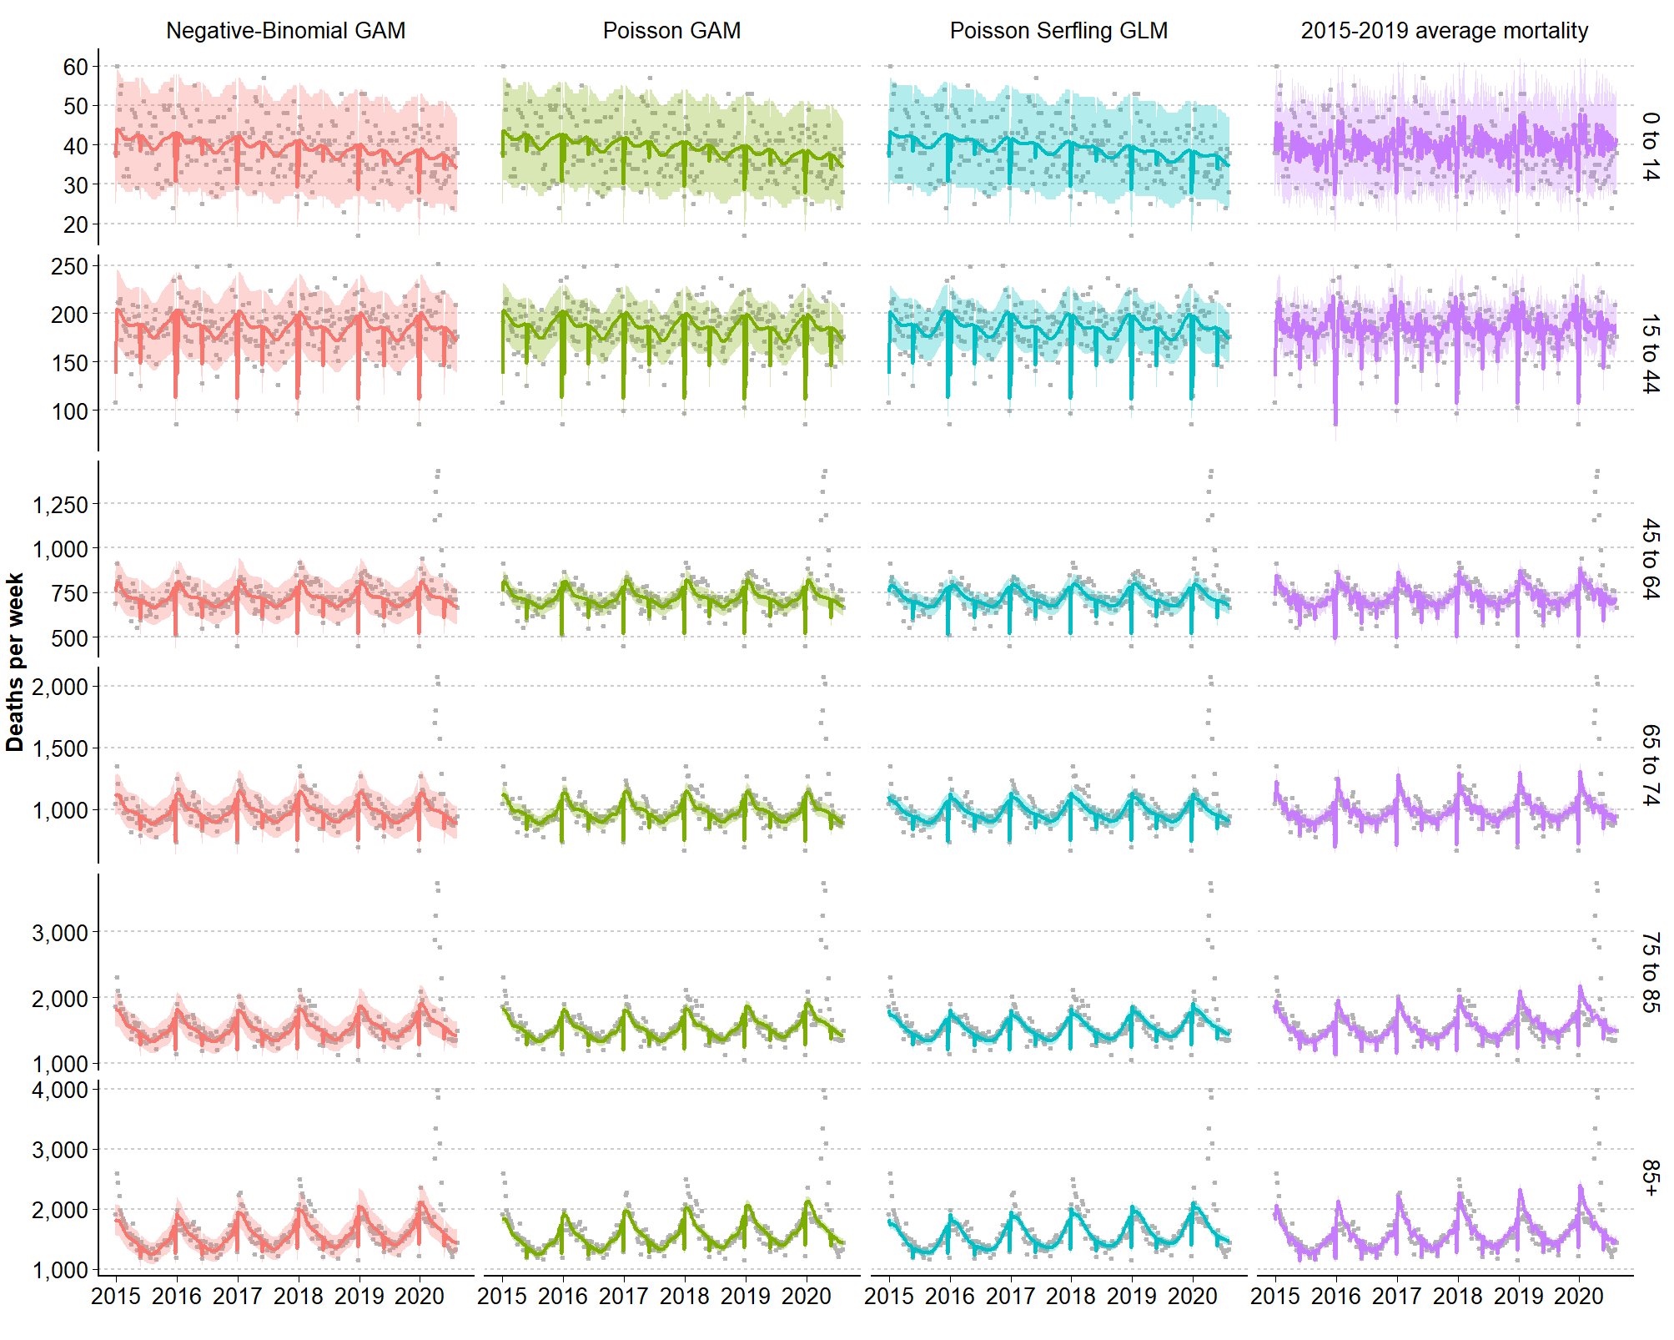

**Figure 2. Expected (lines) vs Observed deaths (points) counts based on the 4 approaches described above for females by age groups (rows) 0-14, 15-44, 45-64, 65-74, 75-84 and 85-older years of age. Shaded areas indicate 95% prediction intervals.**

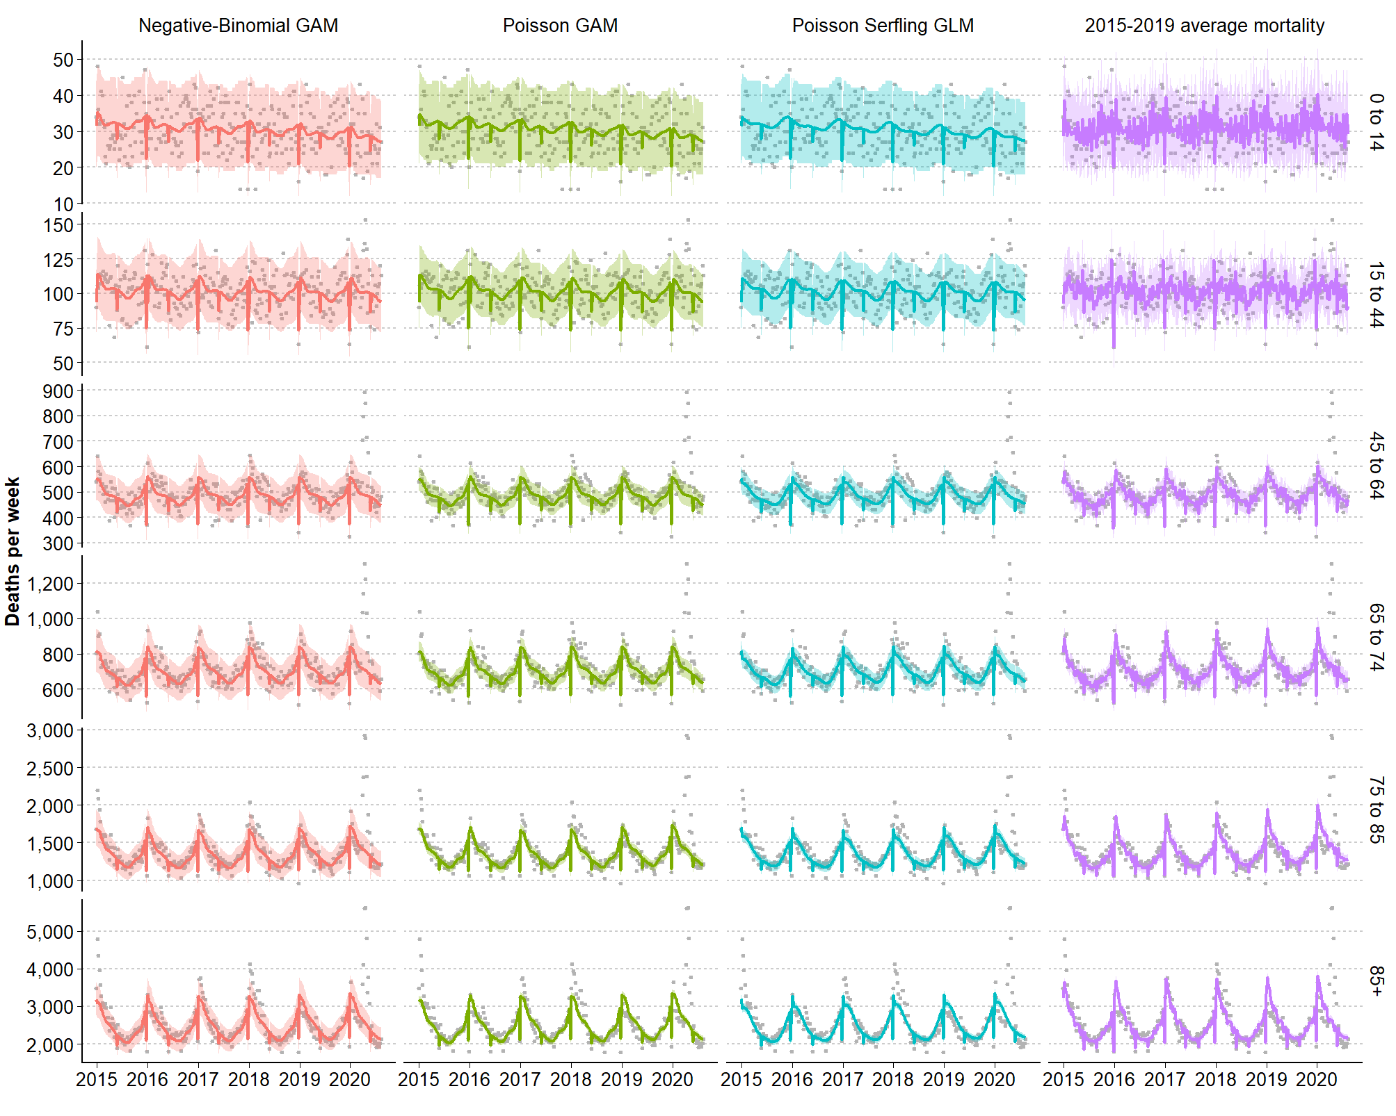

**Figure 3. Sex ratio males/females of death rates during the course of the pandemic by age groups (rows) 0-14, 15-44, 45-64, 65-74, 75-84 and 85-older years of age.**

